**Unit 6 Study Guide**

Name:______________________ Date:________ CP:__

1. Which question would give the best statistical data?
   1. What type of ice cream do you like the best?
   2. Who ran the mile the fastest in gym?
   3. What were the scores on the math test?
2. Which two central tendencies are measures of center?
   1. Range and median
   2. Median and mode
   3. Mean and median
   4. Range and mode
3. Which central tendency is a measure of variation?
   1. Mean
   2. Median
   3. Mode
   4. Range
4. The table shows the number of points scored by the Spurs in their last 4 basketball games. What is the range of the four games listed?

|  |  |
| --- | --- |
| Game | Points |
| 1 | 89 |
| 2 | 94 |
| 3 | 89 |
| 4 | 101 |
| 5 | ? |

1. Using the table from question 4, how many points do the Spurs need to score in game 5 to have a mean score of 90? Use algebra!
2. Find the Interquartile Range (IQR) for the data set: {9,7,9,16,12,15,18}
   1. 25
   2. 7
   3. 3
   4. 4
3. Which two quartiles should you subtract in order to find the IQR?
4. Find the mean of the set of data {2,3,6,7,12,15,18}
   1. 16
   2. 63
   3. 9
   4. 7
5. Find the median according to the line plot below: 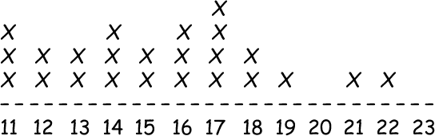
6. Using the line plot from question 9, what is the range of data?
   1. 11
   2. 8
   3. 22
   4. 17
7. Use the test scores of 15 students to create a box and whisker plot: {80,85,75,80,85,90,90,95,85,85,80,100,70,65,80}
8. Based on your box and whisker plot, was this a fair test? Explain!
9. What is the range for the middle 50% of data?
10. Mrs. Buford’s science class takes a test. The mean score on the test is 88% and the median score is 86%. Johnny was absent and takes his test the next day and scores a 40%. What statement reflects most accurate change in the data?
    1. The range will decrease.
    2. The median will decrease a large amount.
    3. The mean will decrease a large amount.
    4. Mrs. Buford’s tutoring class size will increase.

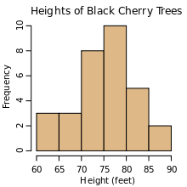**The histogram shows the height of black cherry trees grouped into 5-foot groups.**

15. How many trees were greater than or equal to 75 feet?

16. What interval contains the mode?

17. Create a grouped frequency table based on the information in the histogram.